# TRAFFIC MANAGEMENT SYSTEM

**PROJECT DEFINITION:**

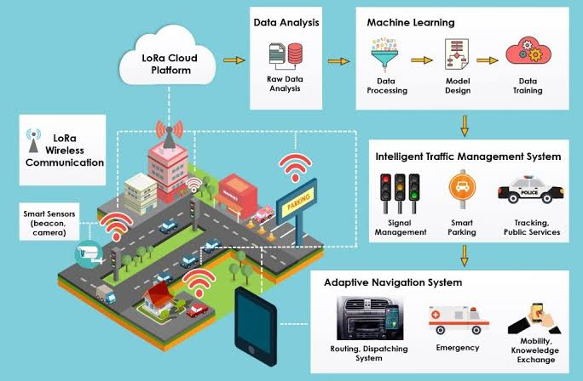A Traffic Management System (TMS) through the Internet of Things (IOT) is a sophisticated system designed to monitor, control, and optimize traffic flow and transportation infrastructure using IOT technologies. It involves the integration of various IOT devices, sensors, and communication networks to collect real-time data from roadways, intersections, and vehicles. This data is then processed and analyzed to make informed decisions, improve traffic flow, enhance safety ,And reduce congestion on roads.

**DESIGN THINKING:**

Design thinking is a problem-solving approach that focuses on understanding and empathizing with users, generating creative ideas, and iterating through prototypes to develop innovative solutions. When applying design thinking to traffic management, you can follow these steps.

**Project objectives:**

Project objectives for a traffic management initiative can vary depending on the specific goals and challenges of the project. However, here are some common project objectives that are often associated with traffic management.

* **Real-time Traffic Monitoring** :This objective involves the continuous and immediate surveillance of traffic conditions on roads and highways using IOT sensors and devices. It aims to provide up-to-the-minute information on traffic flow, road closures, accidents, and other relevant data to both traffic management authorities and drivers.
* **Congestion Detection**: The goal of congestion detection is to identify and assess traffic congestion or gridlock in real-time. IOT sensors and data analysis techniques are employed to detect areas where traffic is slowing down or coming to a standstill, allowing for rapid responses to alleviate congestion and improve traffic flow.
* **Route Optimization**: Route optimization aims to provide drivers with the most efficient and fastest routes to their destinations based on real-time traffic data. By analyzing current traffic conditions, road closures, and accidents, this objective helps drivers avoid traffic jams and reduces travel time.
* **Improved Commuting Experience**: This objective focuses on enhancing the overall experience of commuters and travelers on the road. It includes providing timely traffic updates, alerts about accidents or road hazards, and facilitating smoother traffic flow. Ultimately, it aims to reduce travel stress and make commuting more predictable and enjoyable.

**SENSOR DESIGN:**

Designing an IOT sensor deployment to monitor traffic flow and congestion involves careful planning and consideration of various factors.

* **Traffic Counters sensors:** These sensors are typically placed on roads and intersections to count the number of vehicles passing through a specific location. They provide data on traffic volume, which is essential for traffic flow analysis and congestion detection**.**
* **Inductive Loop Sensors:** Inductive loop sensors are embedded in the road surface and use electromagnetic fields to detect the presence of vehicles. They are often used to Speed sensors, such as RADAR or LIDAR devices, measure the speed of vehicles on the road. They can be used to identify speeding vehicles, monitor average traffic speeds, and trigger speed-related warnings or traffic enforcement.
* **Vehicle Classification Sensors:** These sensors categorize vehicles based on their size, type, or weight. This data is essential for understanding traffic composition and optimizing traffic flow.
* **Video Cameras (CCTV):**  CCTV cameras equipped with computer vision algorithms can monitor traffic, capture license plate data, detect incidents like accidents or breakdowns, and provide visual verification of traffic conditions.
* **Pedestrian Sensors:** These sensors detect the presence and movement of pedestrians at crosswalks or intersections. They help optimize traffic signal timings to accommodate both vehicular and pedestrian traffic.
* **GPS and GNSS Receivers:** Global Positioning System (GPS) or Global Navigation Satellite System (GNSS) receivers in vehicles can transmit real-time location data to traffic management systems, aiding in traffic flow analysis and congestion management.
* **Ultrasonic Sensors:** Ultrasonic sensors use sound waves to detect the distance between the sensor and an object (e.g., a vehicle). They are used for various applications, including vehicle presence detection and adaptive cruise control.
* **Road Surface Condition Sensors:** These sensors monitor road conditions, including surface temperature, moisture, and ice detection. They are vital for maintaining safe road conditions during adverse weather.
* **Traffic Signal Control Sensors:** Sensors at traffic signals monitor the flow of traffic and adjust signal timings in real-time to optimize traffic flow and reduce congestion.

**REAL-TIME TRANSIT INFORMATION PLATFORM:**

Designing a real-time transit information platform involves several key components and considerations.

* **User Interface (UI):**
  + Create an intuitive and user-friendly UI for both web and mobile apps.
  + Display maps with real-time traffic data, routes, and transit options.
  + Implement interactive features for users to explore information easily.
* **Data Sources:**
  + Integrate APIs from transit agencies, GPS providers, and traffic data sources for real-time updates.
  + Use geospatial data to provide accurate location-based information.
* **Features:**
  + Real-time traffic updates.
  + Transit schedules and delays.
  + Route planning and mapping.
  + Public transportation options.
  + Nearby amenities like bus stops, stations, and parking lots.
* **Notifications:**
  + Push notifications for service alerts, delays, or changes.
  + Customizable alerts based on user preferences.
* **Accessibility:**
  + Ensure the platform is accessible to people with disabilities.
  + Implement features like screen readers and voice command support.
* **Personalization:**
  + Allow users to save favorite routes, set preferences, and create profiles.
  + Provide personalized recommendations based on user history.
* **Map Integration:** 
  + Use mapping services like Google Maps or Open Street Map for accurate location visualization.
  + Highlight traffic conditions with color-coded overlays.
* **Monetization:** Consider revenue streams such as ads, premium subscriptions for ad-free experience, or partnerships with transit agencies.
* **Security and Privacy:**
  + Implement robust security measures to protect user data.
  + Comply with privacy regulations and obtain user consent for data usage.
* **Mobile Apps:**
  + Develop native mobile apps for iOS and Android platforms.
  + Optimize for various screen sizes and device capabilities.
  + Enable offline access for critical information.
* **Testing and QA:**
  + Thoroughly test the platform to ensure reliability and accuracy of real-time data.
  + Perform usability testing to gather user feedback.
* **Scalability:**
  + Design the platform to handle high traffic loads during peak hours.
  + Plan for future expansion and integration with additional transit systems.
* **Maintenance and Updates:**
  + Regularly update the platform to keep data and features current.
  + Address user feedback and bug reports promptly.
* **Marketing and Outreach:**
  + Develop a marketing strategy to promote the platform to the public and transit agencies.
  + Consider partnerships with local governments and transportation authorities.

**INTEGRATION APPROACH:**

Designing a web-based platform and mobile apps to display real-time traffic information to the public requires a well-thought-out integration approach to ensure a seamless and effective user experience.

* **Web-Based Platform Development:**
* Build a web-based platform using modern front end frameworks (e.g., React, Angular, or Vue.js) to provide real-time traffic information through a web browser.
* Implement interactive maps and data visualization to display traffic conditions, incidents, and routes.
* **Mobile App Development:**
  + Develop native or cross-platform mobile apps for iOS and Android that consume the unified API to display real-time traffic information.
  + Implement geolocation services to provide location-specific data.
  + Ensure responsive design for various screen sizes and orientations.
* **User Authentication and Profiles:** Implement user authentication and user profile management to allow users to save preferences, set home locations, and receive personalized traffic alerts.
* **Notifications and Alerts:** Develop a notification system that sends alerts to users regarding traffic incidents, road closures, or disruptions in their selected areas. Utilize push notifications for mobile apps.
* **Monitoring and Analytics:** Implement monitoring tools to track system performance and user behavior. Use analytics to gain insights into user engagement and platform usage.
* **Continuous Improvement:** Establish a process for continuous improvement, including regular updates to the platform and apps based on user feedback and emerging technologies.
* **Compliance and Privacy:** Ensure compliance with data protection regulations and user privacy rights. Implement data anonymization and encryption where necessary.

**CONCLUSION:**  
 The conclusion of a traffic management system through IOT (Internet of Things) is that it offers numerous benefits for urban transportation. IOT technology allows for real-time data collection and analysis, which can improve traffic flow, reduce congestion, enhance safety, and minimize environmental impacts. By connecting vehicles, traffic signals, and infrastructure, IOT-based systems enable better decision-making and optimization of traffic patterns.

**Key advantages of IOT in traffic management include:**

* **Real-time Data:** IOT sensors and cameras provide continuous data on traffic conditions, allowing for immediate response to incidents or congestion.
* **Predictive Analytics:** IOT can analyze historical data to predict traffic patterns, helping authorities plan and allocate resources more efficiently.
* **Adaptive Traffic Signals:** Smart traffic signals can adjust in real-time based on traffic volume, reducing waiting times and improving traffic flow.
* **Emergency Response:** IOT enables faster response times during emergencies, such as accidents or road closures, by rerouting traffic and notifying authorities.
* **Environmental Benefits:** Efficient traffic management reduces fuel consumption and emissions, contributing to a greener environment.

In conclusion, IOT-based traffic management systems have the potential to transform urban mobility, making it more efficient, safe, and sustainable. However, successful implementation requires collaboration between government agencies, private companies, and technology providers to ensure data privacy, security, and interoperability.